**SIMPEL QUERY BAGIAN 2**

1. [SELECT](http://localhost/phpmyadmin/url.php?url=https://dev.mysql.com/doc/refman/8.0/en/select.html) * FROM `pembuat_obat` WHERE alamat='bandung';

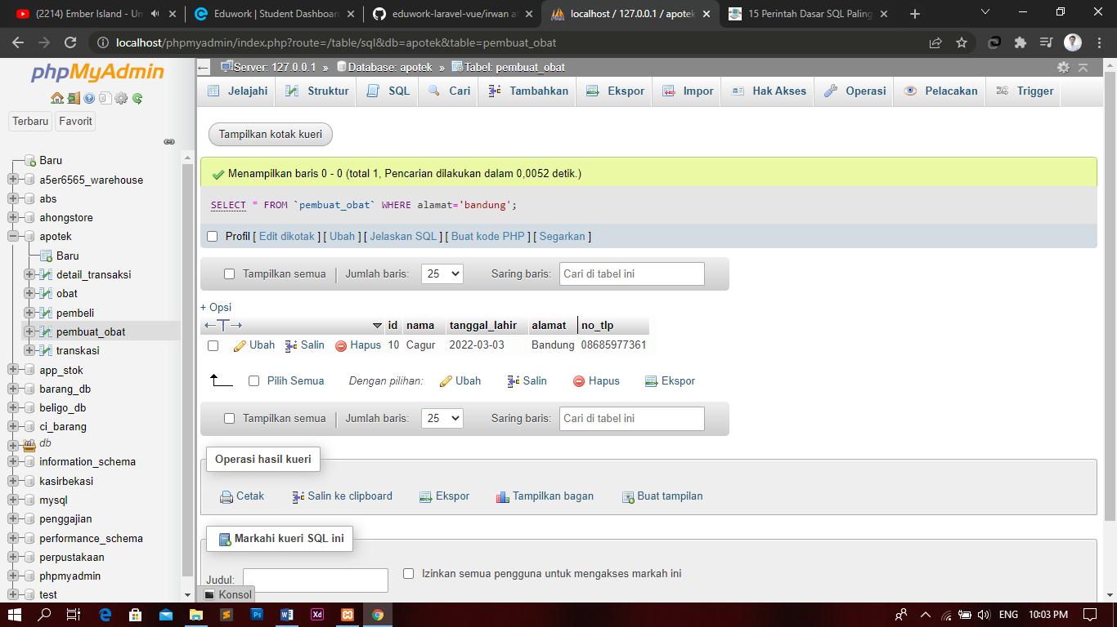

1. [SELECT](http://localhost/phpmyadmin/url.php?url=https://dev.mysql.com/doc/refman/8.0/en/select.html) * FROM `pembuat_obat` WHERE [NOT](http://localhost/phpmyadmin/url.php?url=https://dev.mysql.com/doc/refman/8.0/en/logical-operators.html#operator_not) alamat='Bandung';

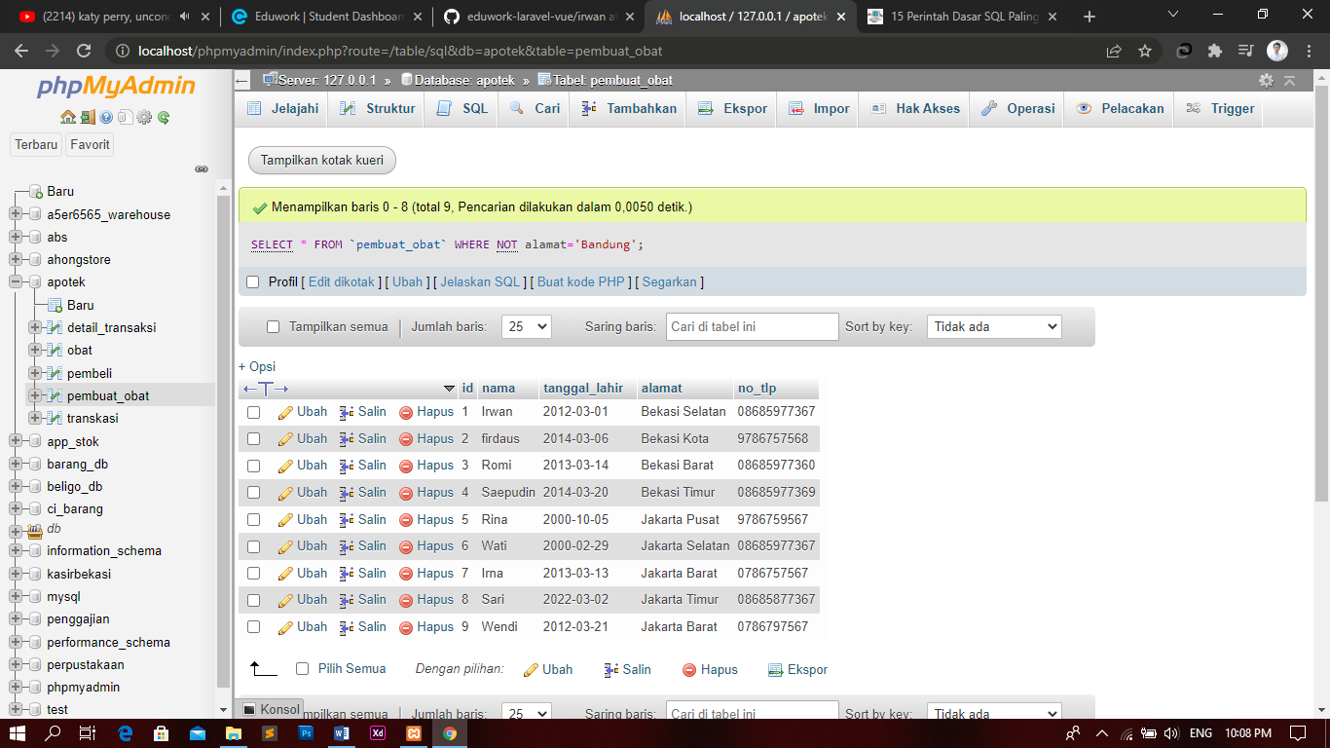

1. [SELECT](http://localhost/phpmyadmin/url.php?url=https://dev.mysql.com/doc/refman/8.0/en/select.html) * FROM `obat` ORDER BY id DESC;

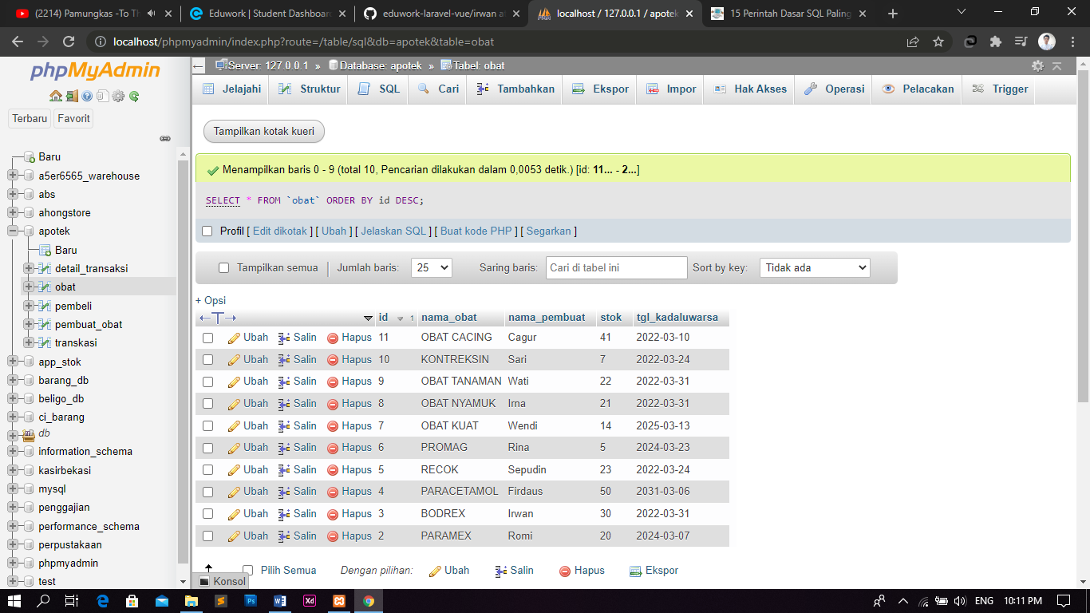

1. [SELECT](http://localhost/phpmyadmin/url.php?url=https://dev.mysql.com/doc/refman/8.0/en/select.html) * FROM `obat` WHERE nama_obat [LIKE](http://localhost/phpmyadmin/url.php?url=https://dev.mysql.com/doc/refman/8.0/en/string-comparison-functions.html#operator_like) '%PARAMEX%';

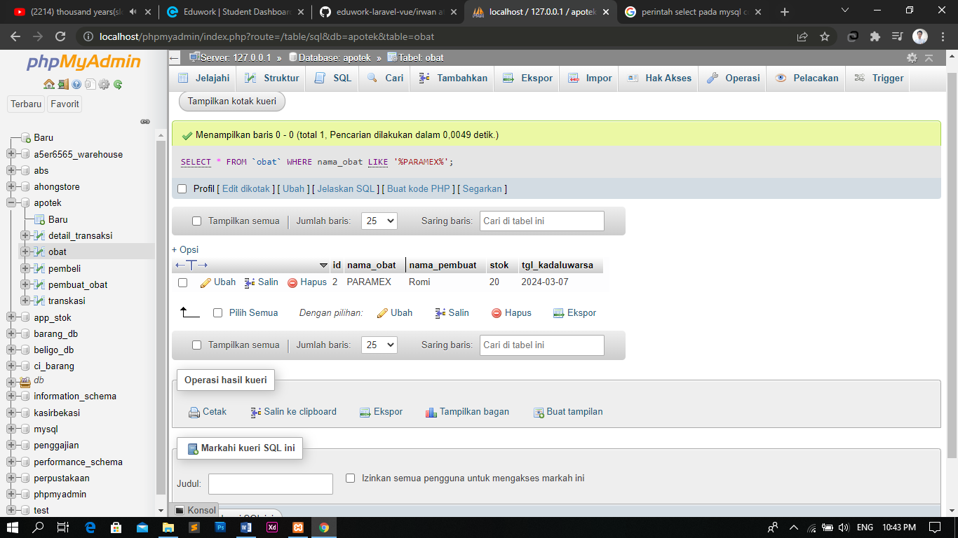

1. [SELECT](http://localhost/phpmyadmin/url.php?url=https://dev.mysql.com/doc/refman/8.0/en/select.html) * FROM `obat` WHERE nama_obat [LIKE](http://localhost/phpmyadmin/url.php?url=https://dev.mysql.com/doc/refman/8.0/en/string-comparison-functions.html#operator_like) '%BODREX%';

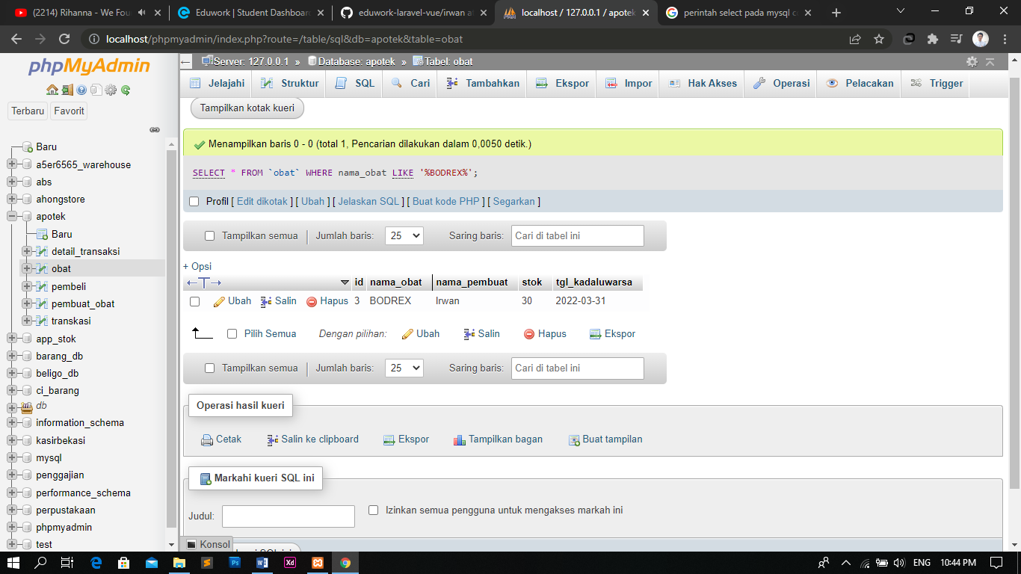

1. [SELECT](http://localhost/phpmyadmin/url.php?url=https://dev.mysql.com/doc/refman/8.0/en/select.html) * FROM `obat` WHERE nama_pembuat [LIKE](http://localhost/phpmyadmin/url.php?url=https://dev.mysql.com/doc/refman/8.0/en/string-comparison-functions.html#operator_like) '%Irwan%';

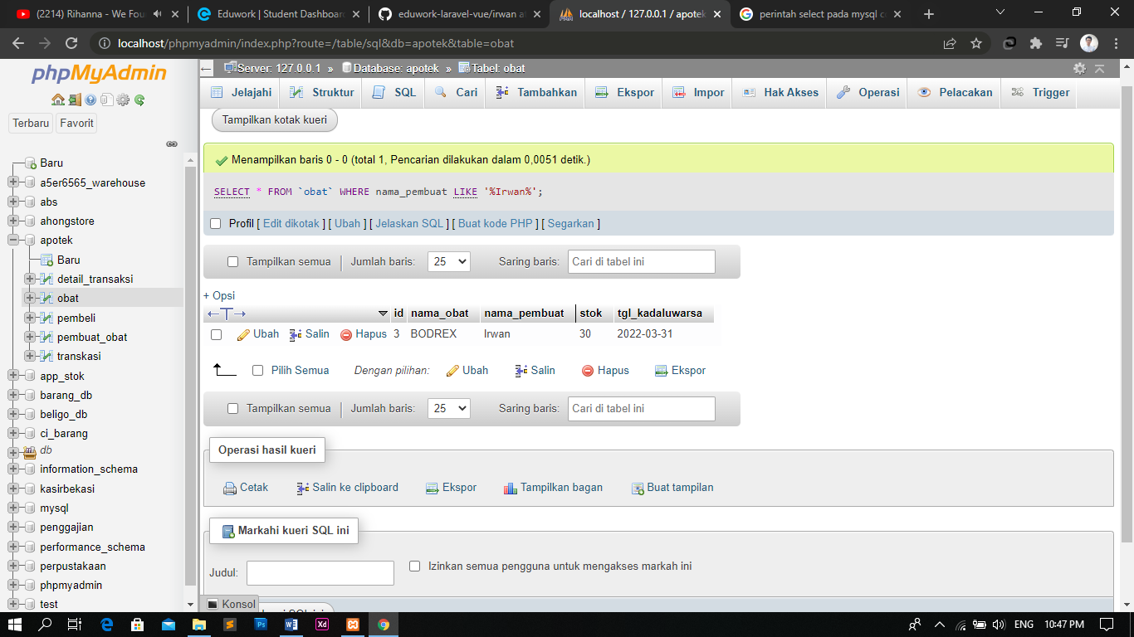

1. [SELECT](http://localhost/phpmyadmin/url.php?url=https://dev.mysql.com/doc/refman/8.0/en/select.html) * FROM `pembuat_obat` ORDER BY alamat ASC;

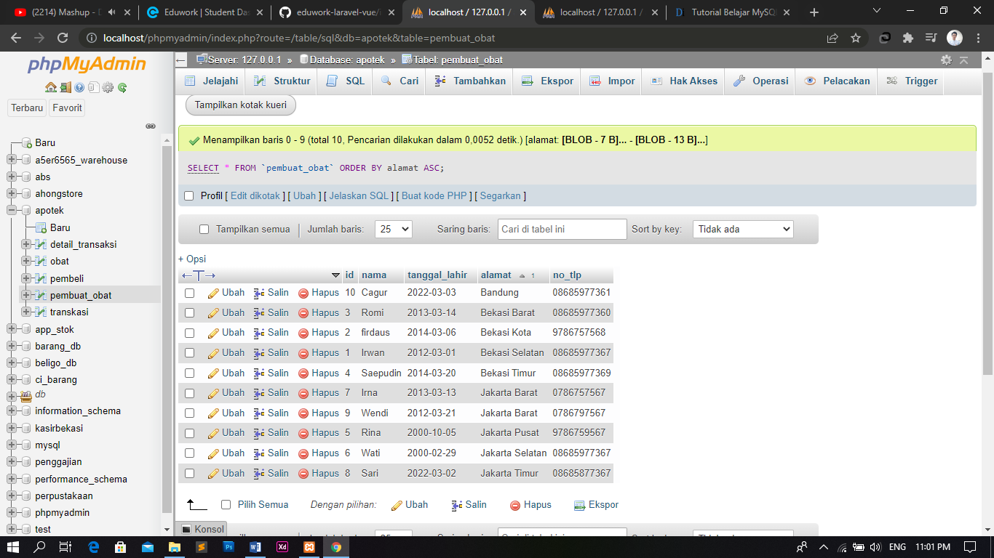

1. [SELECT](http://localhost/phpmyadmin/url.php?url=https://dev.mysql.com/doc/refman/8.0/en/select.html) * FROM `pembuat_obat` ORDER BY nama ASC LIMIT 0,3;

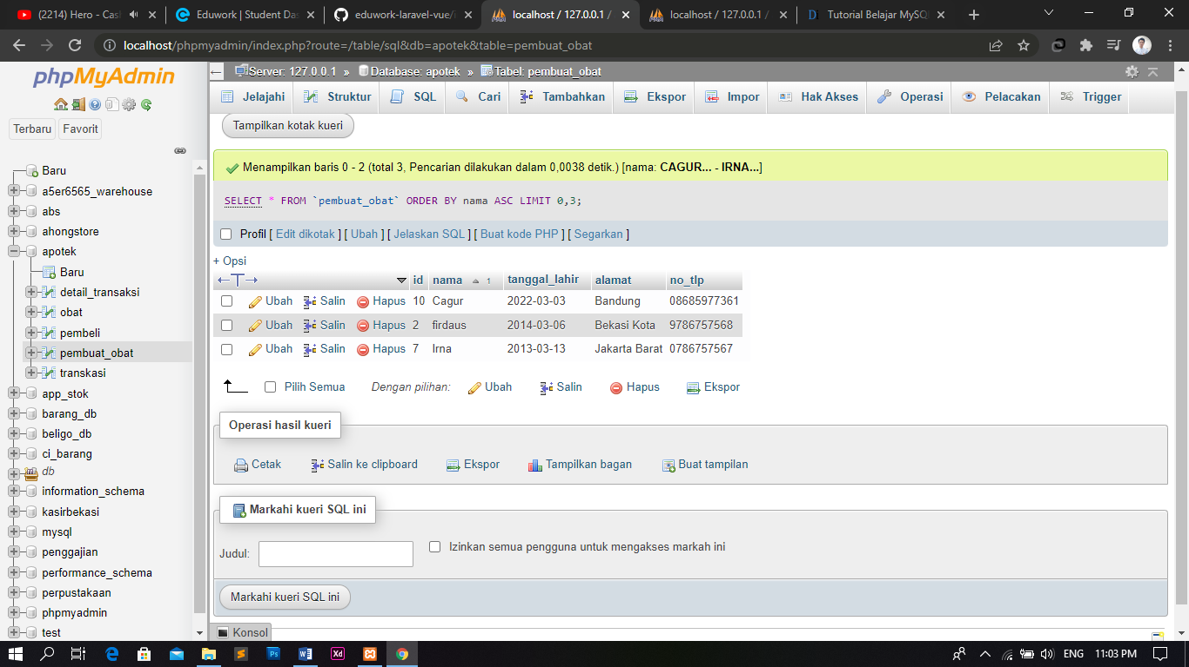

1. [SELECT](http://localhost/phpmyadmin/url.php?url=https://dev.mysql.com/doc/refman/8.0/en/select.html) * FROM `pembeli` ORDER BY alamat LIMIT 5;

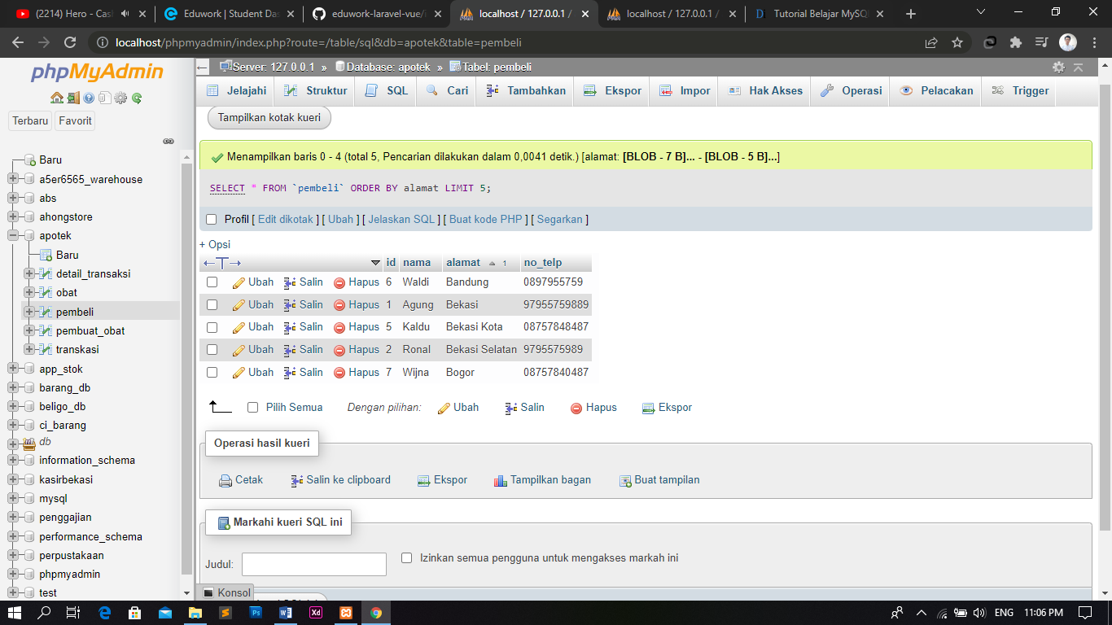

1. [SELECT](http://localhost/phpmyadmin/url.php?url=https://dev.mysql.com/doc/refman/8.0/en/select.html) * FROM `transkasi` ORDER BY nama_pasien ASC LIMIT 0,5;

